## Customer satisfaction is the key to success for any business. In a

restaurant, the traditional hand-waving method for calling services is

inefficient often leading to many complaints. The Restaurant Management

System increases operational efficiency through use of an internal wired

communications system. The communications system increases customer

satisfaction by leaving a system at each table which the customer can use to

request for a server. This system allows managers and owners to easily monitor

restaurant functions and employee progress.

Customer satisfaction is the key to success for any business. In a

restaurant, the traditional hand-waving method for calling services is

inefficient often leading to many complaints. The Restaurant Management

System increases operational efficiency through use of an internal wired

communications system. The communications system increases customer

satisfaction by leaving a system at each table which the customer can use to

request for a server. This system allows managers and owners to easily monitor

restaurant functions and employee progress.

Customer satisfaction is the key to success for any business. In a

restaurant, the traditional hand-waving method for calling services is

inefficient often leading to many complaints. The Restaurant Management

System increases operational efficiency through use of an internal wired

communications system. The communications system increases customer

satisfaction by leaving a system at each table which the customer can use to

request for a server. This system allows managers and owners to easily monitor

restaurant functions and employee progress.

Customer satisfaction is the key to success for any business. In a

restaurant, the traditional hand-waving method for calling services is

inefficient often leading to many complaints. The Restaurant Management

System increases operational efficiency through use of an internal wired

communications system. The communications system increases customer

satisfaction by leaving a system at each table which the customer can use to

request for a server. This system allows managers and owners to easily monitor

restaurant functions and employee progress.

MINI PROJECT REPORT 0N RESTAURENT

* ABSTRACT

Customer satisfaction is the key to success for any business. In a restaurant, the traditional hand-waving method for calling services is inefficient often leading to many complaints. The Restaurant Management System increases operational efficiency through use of an internal wired communications system. The communications system increases customer satisfaction by leaving a system at each table which the customer can use to request for a server. This system allows managers and owners to easily monitor restaurant functions and employee progress.

In many popular restaurants, waiters/waitresses tend to miss out on tables or customers’ calls during busy hours potentially decreasing ones clientele. While this is an ongoing issue, there is still no product that drastically improves the communication between the servers and the customers in the current market. Hence, the goal is to design a system in which the customers can call their servers easily and help the restaurant increase overall efficiency.

* INTRODUCTION

In many popular restaurants, waiters/waitresses tend to miss out on tables or customers’ calls during busy hours potentially decreasing ones clientele. While this is an ongoing issue, there is still no product that drastically improves the communication between the servers and the customers in the current market. Hence, the goal is to design a system in which the customers can call their servers easily and help the restaurant increase overall efficiency. An internal wired communication system will allow prompt notification to the server when a customer requires service. Moreover, servers can also be more focused on serving their current customers and save their time and energy from always keeping an eye out for needy customers.

On top of meeting the needs of customers, restaurant

managers can also monitor the response time of their waiters/waitresses

through use of this system. Hardworking, proficient employees will become

more recognized while lazy, inefficient employees become motivated to improve.

As a result, the restaurant becomes more efficient and possibly increasing

morale while improving the level of customer satisfaction.

On top of meeting the needs of customers, restaurant

managers can also monitor the response time of their waiters/waitresses

through use of this system. Hardworking, proficient employees will become

more recognized while lazy, inefficient employees become motivated to improve.

As a result, the restaurant becomes more efficient and possibly increasing

morale while improving the level of customer satisfaction.

On top of meeting the needs of customers, restaurant managers can also monitor the response time of their waiters/waitresses through use of this system. Hardworking, proficient employees will become more recognized while lazy, inefficient employees become motivated to improve. As a result, the restaurant becomes more efficient and possibly increasing morale while improving the level of customer satisfaction.

* PROJECT OBJECTIVE AND AIM

Now a day, the world is getting into digital world. System was trying to build out to make people even more convenience on any aspects. Restaurant Management System provide an system based food ordering system without help of a waiter. It involves seller and buyer which could bring benefits to each other. It is win-win situation that will bring benefits to the world.

It provides customer with a completely new way to make order. By providing customer convenience and also increase the sales. No time wasted with order taking or letting the customer browse the menu over the system.

This system provides more reliable usability, maintainability and dependability functions. By creating quality, easy to keep track management of new system. So that it can streamline all the works by a simple click. By develop the system based food ordering system can reduce the unnecessary costs such as staff salaries, customer satisfaction, reputation, etc. Our restaurant also easy to keep track for the maintenance and point redemption.

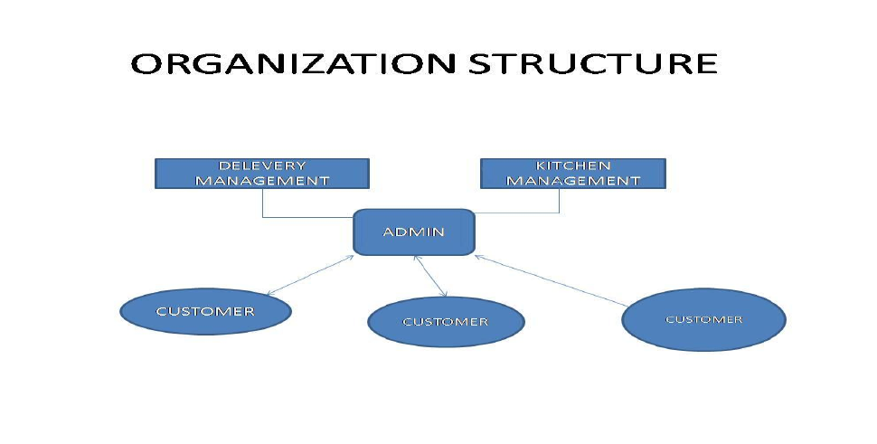

* EXISTING SYSTEM

Today, we will go to a restaurant, then a waiter come and take order. Sometimes the waiter is busy otherwise he is not see me. And he is not take order as soon as possible. We will compare Restaurant Management System between, today system come human errors is possible like can’t take order correctly. We will need to other items we are waiting for their time.

We can see the speciality of Restaurant Management System we can see the price of the item in the menu. But today system we can see the total amount we can see at the last moment. But Restaurant Management System when we take order then we can see the total amount.

* SYSTEM DESIGN

For giving the order, the user should become a member initially. User would have to install his information like the address and other key information so that he doesn’t have to give his information each time. For signing up every customer has to give some this details such as address, name, Contact no etc and the most important is email ID which is the primary key to identify each customer uniquely, thus email becomes the User ID for  the customer

The only thing needed here is to sign in to the system through the system. Now he would have the option to edit his current information and big thing to order the food diminishing the human interaction. He would have today’s menu in front of him and he have the clear choices for order. He has variety of things to do here and have the option to cancel the order before the serving. For the first time to access the system, customer has to give his key information like identification and so on.

For the management side, it is quite possible to book many orders concurrently. System will be able to book nearly infinite number of orders at a time. Management side has more updated information and they can get the currently orders. System will be able to deal with the customers who don’t come to take there orders by blocking them and not letting them to signup again. This is done by maintaining some information regarding the status of order and the relative customer. So according to that the system can deal him. How system deals with him..? He should have to pay the amount of the last order in order to continue with his membership.

At Login page we will be checking the user’s existence and mapping his user ID/email ID with his password, if the user is valid then he is allowed to access further.

CUSTOMER INFO –

This table keeps the record of the customer’s information before user logs on he fills up a form that guides him how he can become a member. Email ID is primary key in this table so we can recognize each member’s email ID uniquely as it is used as their user ID as well. Other information includes customer Name, password, contact no, Address and status, the later tells him about whether the member is blacklisted or locked. The entity shares a 1:N relation with order utilities.,

MENU –

The name insists, it contains the information of all menus and its related matter. Each menu is uniquely identified by its Item ID (Primary key). The purpose here is to provide customers all the information regarding menu such as Name (item), Description, Category, price and status (to check customer, whether that item is currently available or Not!!). Later, at the management’s point of view, we provide user ID (uniquely selected by management staff) to alter the contents of table. This entity shares N:1 relationship with the ordered item entity.

ORDER –

This table tells about the Order ID (which is a primary key), who has placed the order and gives details about the time when order was placed and the time when the order will be delivered; along with the status of the order (usually some 5 status labels are assigned). This table shares N:1 relationship with the Customer info entity.

* DEVELOP MANAGEMENT

PROGRAMING LANGUAGES –

PHP: Hypertext Pre-processor

PHP is a server-side scripting language designed for web development but also used as a general-purpose programming language. PHP is now installed on more than 244 million websites and 2.1 million web servers. Originally created by Rasmus Lerdorf in 1995, the reference implementation of PHP is now produced by The PHP Group. While PHP originally stood for Personal Home Page, it now stands for PHP: Hypertext Preprocessor, a recursive acronym.

PHP code is interpreted by a web server with a PHP processor module which generates the resulting web page: PHP commands can be embedded directly into an HTML source document rather than calling an external file to process data. It has also evolved to include a command-line interface capability and can be used in standalone graphical applications. PHP is free software released under the PHP License, which is incompatible with the GNU General Public License (GPL) due to restrictions on the usage of the term PHP. PHP can be deployed on most web server

* PROBLEM BASED BY CURRENT SYSTEM

SURVICE QUALITY DECREASE

All the food service needed to go through a voice call. When customer make order, staff write down orders. Customer just can make order which they walk in or call. They cannot make order as they like. The accociated benefits will gradually be reflected in our customer service, information management areas. Since all the food ordering done in manual way. So the customer have to queue up to make order.

TIME CONSUMING –

When customer call an waiter during busy time. They cannot make order at the busy time. Otherwise customer can make order waiting until after a period of time. When customer make order, a food getting after a time delay. This experience customer give an unsatisfied  experience.

* FUTURE DEVELOPMENTS –

The main dispatcher system software may have a few areas to improve on in the future. The current system allows anyone to view and modify the database. Adding a user profiles with password will improve the overall security of the system. As for eccentric feature, colour code different request status, request type, or waiter id would make the request table easier to read. In the future, it would be efficient to join this main dispatcher software to the existing ordering software that restaurants use today to increase the productivity

* CONCLUSION

The purpose of the wireless restaurant management system is to improve worker efficiency and to maximize profit margin of restaurant owners by providing better service. Providing prompt response to customers through use of a System and data collection by the Main Dispatcher will allow this to happen. This project proved to be a larger task than expected due to lack of manpower and late arriving parts. Certain functionality also had to be abandoned to meet time constraints. The System is not designed to replace the existing ordering systems which are at many restaurants but to complement it. Once the Restaurant Management System becomes further refined with the ideas discussed in the previous section, it will pose to be an indispensable too